NUMERICAL DIFFERENTIATION

Numerical differentiation is the process of calculating the derivatives of a given function by means of a table given values of that function. That is if (x_{i} , y_{i}) are the given set of values, then the process of computing the values of 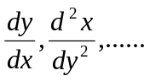etc is called numerical differentiation.
If the values of the derivatives are required at a point near the beginning or the end of the table, we use Newton – Gregory forward and backward formula.
If the values are not equally spaced first find the polynomial by using Lagrange’s formula and then find the derivatives at a point.

FORWARD DIFFERENCE FORMULA TO COMPUTE THE DERIVATIVES
Newton’s forward interpolation formula is
f(x₀ + rh) = y₀ + ry₀ + 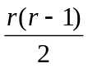² y₀ + 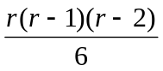³ y₀ + 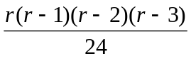⁴ y₀ +...
Differentiating with respect to r we get ,
h f ‘ (x₀ + rh) = y₀ ₊ 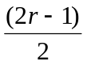 ² y₀ + 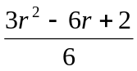 ³ y₀ + 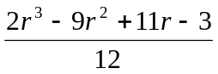 ⁴y₀ +…
h² f ‘’(x₀ + rh) = ²y₀ + (r-1) ³y₀ + 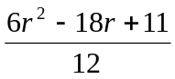⁴y₀ + …..
h³ f ‘’’(x₀ + rh) = ³y₀ + 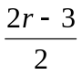⁴y₀ +……
Similarly we want to find the remaining derivatives.
If we want to find the derivatives at a point x = x₀. Then x₀ + rh = x₀ that is r = 0.
Hence on substituting this value of r = 0 in the above formula, we get
f ‘(x₀) = 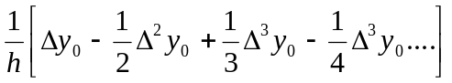
f ‘’(x₀) = 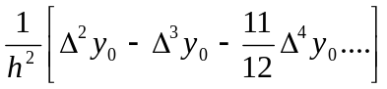
f’’’(x₀) = 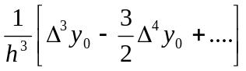 and so on.

BACKWARD DIFFERENCE FORMULA TO COMPUTE THE DERIVATIVES

Newton’s backward difference formula is
f(x₀ + rh) = y₀ + r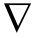y₀ + 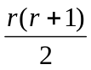² y₀ + 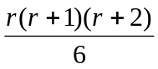³ y₀ + 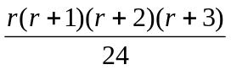⁴ y₀ +..
Differentiating with respect to r we get,
h f ‘ (x₀ + rh) = y₀ ₊ 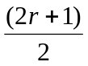 ² y₀ + 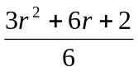 ³ y₀ + 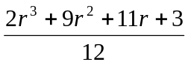 ⁴y₀ +…
h² f ‘’(x₀ + rh) = ²y₀ + (r+1) ³y₀ + 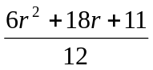 ⁴y₀ + …..
h³ f ‘’’(x₀ + rh) = ³y₀ + 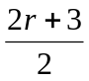 ⁴y₀ +……
Similarly we can find the remaining derivatives.
At the point x = x₀, we have r = 0.
f ‘(x₀) = 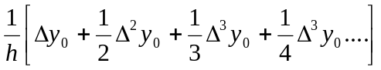
f ‘’(x₀) = 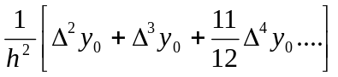
f’’’(x₀) = 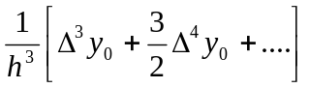 and so on.

EXAMPLE PROBLEMS
Example : 1
Find the first, second and third derivatives of the function tabulated below at the point
x = 1.5
x : 1.5 2.0 2.5 3.0 3.5 4.0
f(x): 3.375 7.0 13.625 24.0 38.875 59.0

Solution :
The table of the difference is follows:
x y = f(x) y ²y ³y ⁴ y
1.5 3.375
3.625
2.0 7.0 3.0
6.625 0.75
2.5 13.625 3.75 0
10.375 0.75
3.0 24.0 4.50 0
14.875 0.75
3.5 38.875 5.25
20.125
4.0 59.0

Here we have to find the derivative at the point x = 1.5 which is the starting value of the table.
Therefore by Newton’s forward difference formula for derivatives at x =x₀, we have
f ‘(x₀) =
Here x₀ = 1.5, h = 0.5
Therefore,
f ‘(1.5) = 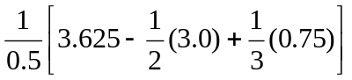
f ‘(1.5) = 4.75
At the point x = x₀
f ‘’(x₀) =
f ‘’(1.5) = 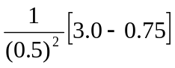
= 9.0

f’’’(x₀) =
f’’’(1.5) = 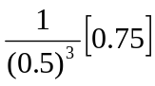
= 6.0

Example : 2
The population of a certain town is shown in the following table
Year : 1931 1941 1951 1961 1971
Population :40.6 60.8 79.9 103.6 132.7
(in thousand)
Find the rate of growth of the population in the year 1961.

x y = f(x) y ²y ³y ⁴ y
1931 40.6
20.2
1941 60.8 -1.1
19.1 5.7
1951 79.9 4.6 -4.9
23.7 0.8
1961 103.6 5.4
29.1
1971 132.7

Here h = 10, x₀ = 1971.
We know that
h y ‘ (x₀ + rh) = y₀ ₊ ² y₀ + ³ y₀ + ⁴y₀ +…
We have to find the rate of change of population in the year 1961.
i.e., y’ (1961) = ?
i,e., x₀ + rh = 1961
1971 + r.10 = 1961
r = 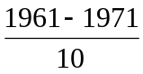 = -1
Substituting r = -1, h = 10, we get
y’ (1961) = 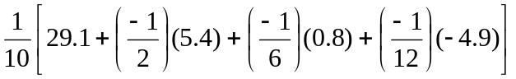
= 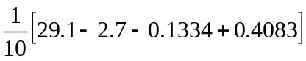
= 2.6775

Therefore the rate of growth of the population in the year 1961 is 2.6675.

Example : 3
A rod is rotating a plane. The following table gives the angle(radians) through which the rod has turned for various of the time t seconds.
t : 0 0.2 0.4 0.6 0.8 1.0
: 0 0.12 0.49 1.12 2.02 3.20
Calculate the angular velocity and the angular acceleration of the rod when t = 0.6 seconds.

Solution :
The table of difference is as follows:

x y = f(x) y ²y ³y ⁴ y
0 0
0.12
0.2 0.12 0.25
0.37 0.1
0.4 0.49 0.26 0
0.63 0.1
0.6 1.12 0.27 0
0.90 0.1
0.8 2.02 0.28
1.18
1.0 3.20

Using Newton’s backward difference formula for derivatives, we have
h y ‘ (x₀ + rh) = y₀ ₊ ² y₀ + ³ y₀ + ⁴y₀ +…
Here h = 0.2
To find the angular velocity when t = 0.6 seconds, i.e.,at x = 0.6
y‘ (0.6) = ?
x₀ +rh = 0.6
- + r(0.2) = 0.6
r = -2
y’ (0.6) = 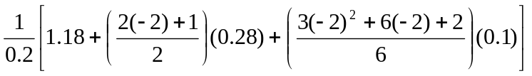
= 3.966 radians / sec
Hence the angular velocity is 3.966 radians / sec.
To find angular acceleration :
We know that y ‘’ (x₀ + rh) = 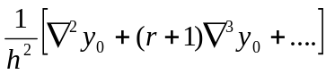
y ‘’(0.6) = 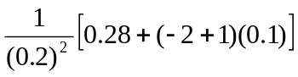
= 4.5 radians / sec².

Example : 4
From the following table, obtain second derivative at the point x = 0.96
x : 0.96 0.98 1.00 1.02 1.04
f(x) : 0.7825 0.7739 0.7651 0.7563 0.7473
Solution :
The table of difference is as follows :

x y = f(x) y ²y ³y ⁴ y
0.96 0.7825
-0.0086
0.98 0.7739 -0.0002
-0.0088 0.0002
1.00 0.7651 0 -0.0004
-0.0088 -0.0002
1.02 0.7563 -0.0002
-0.0090
1.04 0.7473

Using Newton’s forward interpolation formula for derivatives at the point x = x_{0,} we have
y ‘’(x₀) =
Here x = 0.96, h = 0.02
Therefore
y‘’(0.96) = 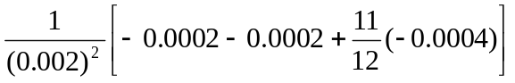

= -1.91675

EXERCISE PROBLEMS
1. Find the value of y if f(y) = 0.3887 from the table given below
x : 21 23 25
y : 0.3706 0.4068 0.4433
2. Find f ‘ (5) and f ‘’(5) using the following data
x : 0 2 3 4 7 9
y : 4 26 58 112 466 922
3. Compute f ‘(3.5) and f ‘’(4) given that f(0) = 2; f(2) = 12 and f(5) = 147.
4. Find the value of f ‘’(3) using divided differences, given data
x : 0 1 4 5
y : 8 11 68 123
5. Find the first and second derivative of y at x = 15 from the table below.
x : 15 17 19 21 23 25
y : 3.873 4.123 4.359 4.583 4.796 5.000
6. Find the first two derivatives of y at x = 54 from the following data
x : 50 51 52 53 54
y : 3.6840 3.7084 3.7325 3.7563 3.7798

